DATA 301 Notes October 14th

* 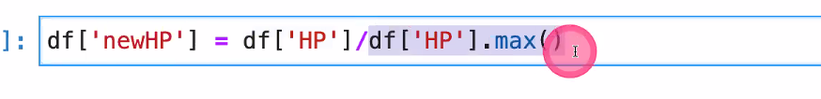
* Creates new column ‘newHP’ which divides ‘HP’ by ‘HP.max()
* Make histogram:
* 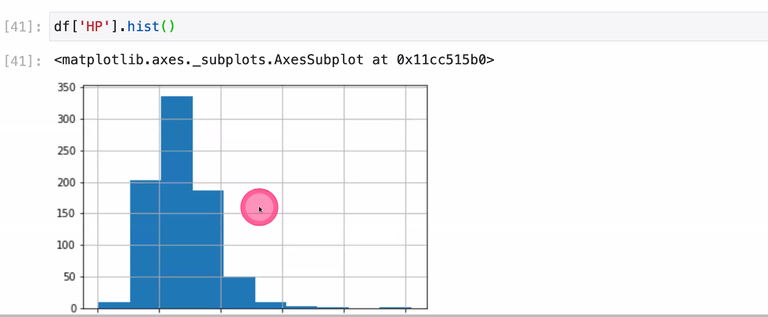

Loops and iteration

* A for loop repeats statement a number of times
* Col_names= [‘HP,’Attack’,’Defense’,’Speed’]
  + For col in col_names:
  + Print(col,df[col].mean())
* Df.columns[